Buggy TLC - BOS (Buggy Operating System) 2021 User Manual

**Version 0.1**



**Table of Contents**

1. **What is Buggy TLC?**
2. **Welcome to the user manual**
3. **Getting started**
4. **What is BOS?**
5. **Log-in**
   1. Username
   2. Password
6. **Drivers Page**
   1. Search bar
   2. Filter by Stage
   3. Car Status
   4. Add a New Driver
   5. Tags
7. **Non-TLC Driver (Empire_Rentals)**
8. **Collections** 
   1. Personal Collection Chart
   2. Number of Drivers on Collection Board
   3. All Billing Days
   4. Search Bar
   5. Filter by Active
   6. Rep
   7. Car Status
   8. Show Hidden
   9. Min Balance - $0
   10. Max balance - $10000
   11. Filter by Payment Method
   12. Filter by Payment Day
   13. TLC/Non-TLC filter
   14. Tags
   15. Pending Zelle Transactions
   16. Hide Drivers
   17. Message Button
9. **Applications**
   1. New Applications
      1. TLC Drivers
      2. Non-TLC Drivers
   2. Pending Insurance
   3. Denied
   4. Didn’t take the car
   5. All Applications
   6. Search Bar
   7. Rep
   8. Filter by Insurance Status
10. **Cars**
    1. Cars in Fleet board
    2. Upcoming Returns board
    3. Cars
    4. Confirmed Returns
    5. Future Returns
    6. Tags
    7. Search bar
    8. Car Models
    9. Location Zones
    10. Model Group Type
    11. All Stages
    12. Onsched Filter
    13. All Ready Status
    14. Action Button
        1. Installed Items
11. **Car Issues**
    1. Open Alerts board
    2. Urgent Alerts board
    3. Open & Closed in Range
    4. Add Issue + button
    5. Search bar
    6. All Car Stages
    7. All Urgent & Open
    8. All Types
12. **Reserved Cars**
    1. Reservations in Total board
    2. Reservation Status board
    3. Pickup Types board
    4. Search bar
    5. Pickup Type
    6. Assigned To
    7. Pickup Location
    8. Car Status
    9. Cars Location Zones
    10. TLC/Non-TLC Filter
    11. New Reservation button
13. **Available Cars**
    1. Cars in Fleet board
    2. Upcoming Returns board
    3. Cars
    4. Confirmed Returns
    5. Future Returns
    6. Tags
    7. Search bar
    8. Car Models
    9. Location Zones
    10. Model Group Type
    11. All Stages
    12. Onsched Filter
    13. All Ready Status
    14. Action
        1. Installed Items
14. **Awaiting Reservations**
    1. Reservations in Total board
    2. Reservation Status board
    3. Pickup Types board
    4. Search bar
    5. Pickup Type
    6. Assigned To
    7. Pickup Location
    8. Pickup Day
    9. Agreement Type
    10. Base Status
    11. Insurance Broker
    12. TLC/Non-TLC Filter
    13. New Reservation button
15. **All Reservations**
    1. Reservations in Total board
    2. Reservation Status board
    3. Pickup Types board
    4. Search bar
    5. Pickup Type
    6. Agreement Type
    7. Stages
    8. TLC/Non-TLC Filter
    9. New Reservation button
    10. Message Button
16. **All Rentals**
    1. Search bar
    2. Filter by Stage
    3. Car #
    4. Name
    5. Weekly Charge
    6. Start Date
    7. End Date
    8. Nex Rent
    9. Stage
    10. Action
        1. Open Profile
17. **Awaiting Closeout**
    1. Search bar
    2. Filter by Stage
    3. Car #
    4. Name
    5. Weekly Charge
    6. Start Date
    7. End Date
    8. Nex Rent
    9. Stage
    10. Action
        1. Cancel Return
        2. Close Return

# 

# 

# **What is Buggy TLC?**

**Buggy** is a data-centric Global company, providing the asset side of the ride-hailing industry. We offer vehicles that are fully insured and maintained and ready to be driven on ride-hailing networks like Uber, Lyft, and Via. **Buggy** offers affordable **TLC** car rentals to New York City Rideshare drivers and is one of the market-leading companies.

* **Website:** [http://www.joinbuggy.com/](https://www.linkedin.com/redir/redirect?url=http%3A%2F%2Fwww%2Ejoinbuggy%2Ecom%2F&urlhash=Zyje&trk=about_website)
* **Industries:** Automotive
* **Type:** Privately Held
* **Company Size:** 51-200 Employees
* **Specialties:** TLC Rentals, Uber Partner, Wheelchair Accessible Vehicle, Ride-Hailing, and Transportation.

**About Us:**

**Buggy** was founded in **2013** and primarily operates in markets where we can provide value to drivers; either because of local regulation or the credit markets. Buggy recognizes that driver satisfaction is integral to the success of the ride-hailing industry and is committed to providing well-maintained vehicles and exceptional customer service, all at an affordable price, using integrated data and technology. Buggy has a strategic relationship with Uber as one of its select Vehicle Solution Providers and also works with other organizations. The headquarters of Buggy TLC is in Brooklyn, NY.

**Find Us at:**

Buggy **Brooklyn** Office: **445** Empire Blvd, Brooklyn, NY

Buggy **Bronx** Office: **691** Burke Ave, Bronx, NY

Buggy **Maintenance** Shop: **391** Empire Boulevard, Brooklyn, NY

Buggy **DMV** Inspection Shop: **469** Troy Avenue, Brooklyn, NY

Buggy **Tire** Shop: **460** Troy Avenue, Brooklyn, NY

**Operations Department:**

**Buggy** has achieved the top-market-place in the automotive industries but it wasn’t done all alone. As the famous quote goes **“Teamwork** makes the **dream work”** that’s true when it comes to the work and achievement in Buggy. The staff lives like a big happy family, where the departments work together like partners that enable 100% work efficiency and effectiveness. We have several departments performing their best to achieve all the goals. As **Phil Jackson** said, “The **strength** of the team is each **member**. The **strength** of each member is the **Team**”. As we know that Teamwork divides the task and multiplies the success. As the famous American industrialist, business magnate, and founder of the Ford Motor Company, **Henry Ford** said, “If everyone is moving forward together, then success takes care of itself.”

**Buggy** is standing tall among all the top-best companies in this industry with the hard work, smart work, and collaboration of the departments which are mentioned below:

* Car Assignment Department
* Front Desk
* Virtual Representative Department
* Billing Department
* Maintenance Department
* Retention Department

**How does Buggy work?**

In this section, we will learn the actual **driver story** and the whole process driver goes through including the **roles & responsibilities** of the departments step by step.

**“Car Assignment Department (1)”**

1. The Car Assignment or CA department calls the customer and assists them with all the required information, also the department deals with the incoming calls of the customer who wants to rent a car with Buggy TLC, it can be a new customer or an old customer who rented a car in the past.
2. If a customer is satisfied with the given car and price information, then the CA department sends them an application link to fill out the form to have their documents and basic information. After that, the department checks the eligibility & insurance criteria of the customer.
3. If the customer is eligible to work with Buggy TLC and the insurance is approved, then the CA department sends a confirmation text message with the scheduled appointment details including the car and weekly rental information.

**“Front Desk (2)”**

1. When the driver comes to the office, he is welcomed by the Front Desk agents who help the customer with the basic information and in case the customer needs any help they are there to assist them in the best possible ways.
2. Then, the customer is directed to the virtual representative’s booth.

**“Virtual Representative Department (3)”**

1. The virtual representatives are sitting on the screen in each booth to help the customer to be a Buggy driver.
2. The customer comes in, gets all the information again, reconfirms the commitments and price agreements, pays a security deposit. Then signs the contract, checks out the car, and leaves happily as a Buggy driver.

**“Billing Department (4)”**

1. The driver has the car, making trips with Uber, Via, and Lyft earning a good amount of money and after one week on the billing/invoice day, the driver receives a text message with the due balance and preferred payment method (if specified by the driver).
2. Then our billing department ensures that every driver is paying the weekly rental on time by reaching out to the driver through text message or call.

**“Maintenance Department (5)”**

1. The maintenance department is responsible for making sure that the driver’s car is fully maintained. They notify drivers in case their vehicle requires **oil change** service, **TLC** inspection, or **DMV** inspection.
2. This department plays a crucial role in making life easy for the drivers by guiding them in case they need any assistance regarding any maintenance issues of the car.
3. In the worst-case scenario, when a driver needs a **Tow service** or is stuck somewhere, this department plays a significant role in solving the problems.
4. This department also helps the customer with uploading the documents of the car on Uber, Via, or Lyft.

**“Retention Department (6)”**

1. Last but not least is the Retention Department, which plays a role in retaining the drivers if they decide to leave the company.
2. There could be several reasons for the customer to leave like there could be a communication problem, rent is high (not affordable), the driver is going on vacation, finished with Uber, the driver is not satisfied with the services, or found another job.
3. This department reaches out to the drivers, asks their issues, empathizes with them, helps them get the issue fixed, and in the end, retains the drivers.

This is how our departments work and the Buggy has achieved the best ranking and rating among the top companies in this industry.

**Recommended video link to watch the driver story in Buggy TLC:**

[TLC Car Rental | BUGGY TLC RENTALS, Best TLC Fleet In NYC | BOOK NOW](https://youtu.be/m5xH7nUzdws)

# **Welcome to the user manual**

This user manual has been designed according to the needs of the users depending on the departments they belong to. This user manual is to help the users to be well-aware of the use of the Buggy Operating System known as BOS so that they can perform their tasks efficiently and effectively.

* This is the first user manual **Version 0.1** and more versions of it depending on the changes and developments will be published.
* This manual involves pictures of the text.

**Getting started**

**What is BOS, Why is it used?**

**BOS**, also known as **“Buggy Operating System”** is used to manage, create, store and update the data of the drivers, cars, and their agreements on a web-based platform. It also involves creating reservations, running pick-ups, managing payments, scheduling returns, and switches in it.

**BOS** has a Menu on the side which include the options mentioned below:

* Drivers
* Non-TLC Drivers
* Collections
* Applications
* Cars
* Car Issues
* Reserved Cars
* Available Cars
* Awaiting Reservations
* All Reservations
* All Rentals
* Awaiting Closeout

Since this has been used in all the departments and involves all the data handling in it including crucial parts like billing, insurance charge, and returns, this user manual will be a great help to all the staff working in operations. This User Manual will be a guide to each user irrespective of their department in the operations. This User Manual has all the functionality, examples, and procedures in it.

**Log-in:**

Buggy will provide the user with the credentials to use the BOS, it will include a 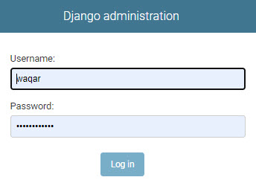

username and password.

Above is an example of the **Log-in** page

* **Username:**

A username will be used to fill out the user field on the log-in page.

* **Password:**

A password will be used to fill out the password field on the log-in page.

Once a user clicks on the **Log-in button** it takes the user to the default page which is the **“Drivers”** Page.

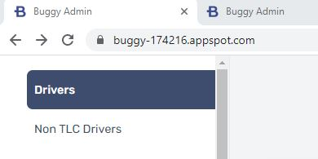

Above is an example, how a **BOS Tab** looks like in a browser.

**Drivers Page:-**

The **“Drivers”** page includes a **search bar**, **stages by the filter, car status,** and option to add a **new driver button** and put **Tags** on the driver’s profile. 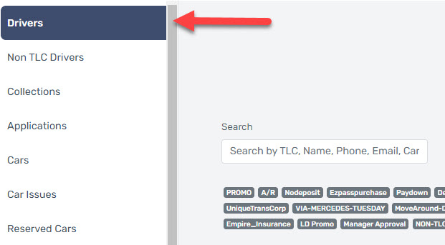

Above is an example of the **Drivers** Page

**Search bar:**

In the **search bar**, the driver can be searched by entering the **driver's name, TLC license number, Phone number, email address, or car id**.

* **Name:**  
   A driver can be searched by entering the name of the driver but since the BOS works with the relevant search other drivers having the same name might show up.
* **TLC License:**

A TLC license is a license given by the Taxi & Limousine Commission to the person, eligible to drive the car for the taxi or limousine services. Only TLC License holders can drive the car for commercial purposes.

* **Phone Number:**

A phone number is necessary to contact the driver via call or text message.

* **Email address:**

An email address is necessary to send the rental contract, important documents, important notices and used for formal purposes.

* **Car id:**

A car id is an identification number, every car in Buggy has a special car id number to find out the car in BOS and to easily assign it to the drivers.

**Filter by Stage:**

The use of the **“filter by stage”** is that a user can check if the driver has an **active status**, **inactive status**, **applied status** or **Didn’t take the car** **status**. A driver can be searched separately on each of them or can be searched by setting the ‘filter by stage’ on **all.**

* **Active Status:**

Active status indicates that a driver is currently working with Buggy. 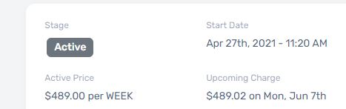

Above is the image of the Stage of **the Active driver**

* **Inactive status:**

Inactive status indicates that a driver is not currently active with Buggy but the driver was associated with Buggy in the past.

Above is the image of the Stage of **Inactive Driver**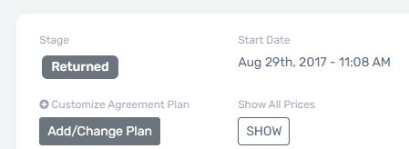

* **Applied Status:**

Applied status indicates that a driver had filled out the signup application and applied for the pick-up of a car.

* **Didn’t take the car Status:**

**Didn’t take the car** status indicates that a registered driver who applied for a car (**new or returning**) but didn’t pick up the car. In this case, the user reaches out to the driver again to schedule an appointment for pick up again.

**Car Status:** Car Status is another feature that helps the users to search for the cars which are **Disabled** or **Enabled** by Buggy.

* **Disabled:**

Disabled status indicates that the car is disabled from the tracker by the user and is not turning on. The driver needs to contact Buggy representatives to get the tracker enabled.

* **Enabled:**

Enabled Status indicates that the car is Enabled from the tracker and is turning on.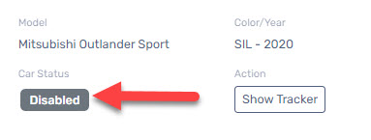

Above is an example of the status of the car as **“Disabled”**

**Add a New Driver Button:**

Add a New Driver button is used to add a new driver in the BOS, it will ask for the driver details such as Driver’s name, email, number, address, TLC License (If TLC driver), and the DMV License.

After adding the information in the required fields, the user will click on the add new driver button and the profile of the driver will be created in the BOS. 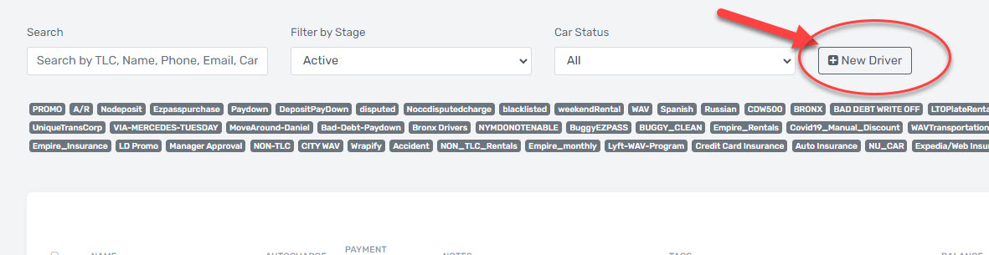

Above is the image of the **“New Driver button”**

**Tags:**

This feature allows the user to search the driver with a specific tag. If a driver’s profile needs special attention like the driver is on a payment plan or if it’s a Bronx Driver or it’s a Non-TLC Driver, the driver’s profile is tagged with (Paydown), (Bronx Drivers) or (Non-TLC or Empire Rentals).

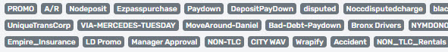

Above is the example of the **Tags**

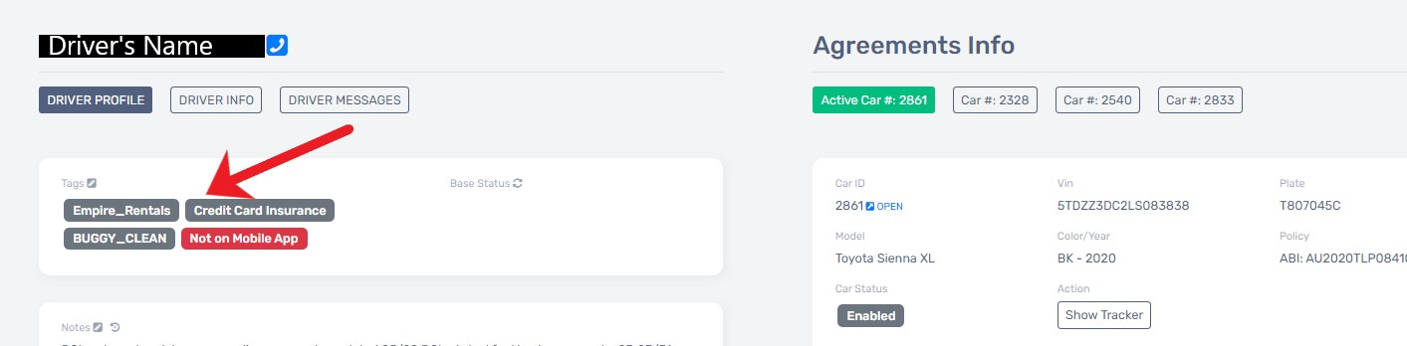

Above is an example of the **“Tags”** on a Driver’s profile.

**Non-TLC Drivers Page:-**

The **“Non-TLC Drivers”** page includes a **search bar**, **stages by a filter, car status,** and option to add a **new driver** and **Tags** just like the Drivers page but this page is just for Non-TLC Drivers. It has all the same features as the Drivers page has but only for the **Non-TLC** **Drivers** and **Non-TLC Cars** search.

Above is the image for the **Non-TLC** **Drivers Page**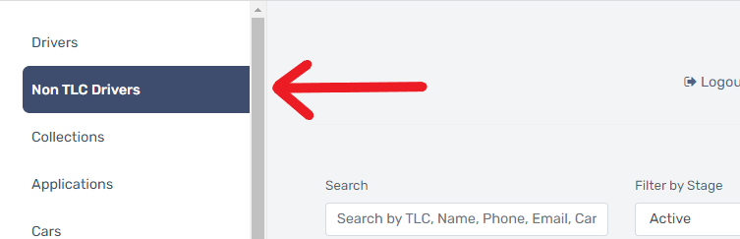

**Non-TLC Drivers:**

Non-TLC drivers are the ones who pick up the car for regular/personal use, not for commercial use, they don’t have a TLC license and they cannot drive with Uber, Via, and Lyft. The Non-TLC driver’s page has all the data available concerning the Non-TLC drivers.

Non-TLC drivers have a few different scenarios than TLC drivers.

* The billing scenario with the Non-TLC drivers is different as they have to pay the rental up-front to drive the car.
* Non-TLC drivers are currently driving with **Empire Rentals.**
* Non-TLC drivers have to pay in case they want to extend the rental or to get it rescheduled for the next dates.
* Non-TLC drivers pay less rental for a car than TLC drivers.
* Non-TLC drivers can return the car exactly at the time they pick up the car from the office.
* Non-TLC Drivers pay through Credit/Debit Card.

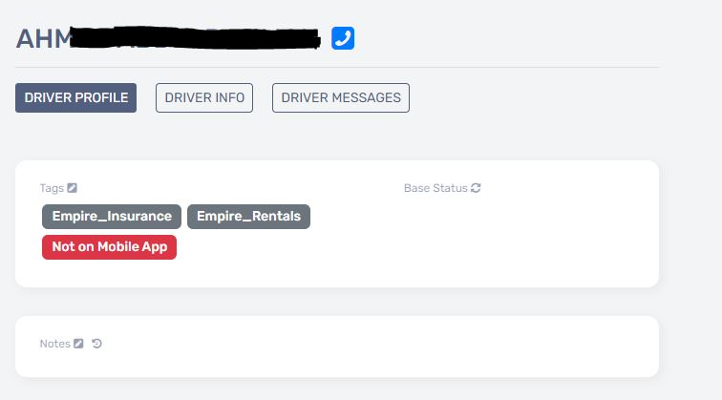

Above is an image of the **Non-TLC Driver** with **Empire_Rentals Tag**

**Collections Page:-**

The **“collections”** page is the page where you find all the information related to the billing of the drivers, it includes a **Personal Collection Chart**, **Number of** **Drivers on Collection Board**, search with **All** **Billing Days**, **a Search Bar**, **Filter by Active**, **Rep, Car Status, Show Hidden, Min Balance $0, Max balance $10000, Filter by Payment Method, Filter by Payment Day, TLC/Non-TLC filter, Tags,** **Pending Zelle Transactions** and the assigned drivers to a user will be displayed on this page.

Above is the image of the **“Collections page”**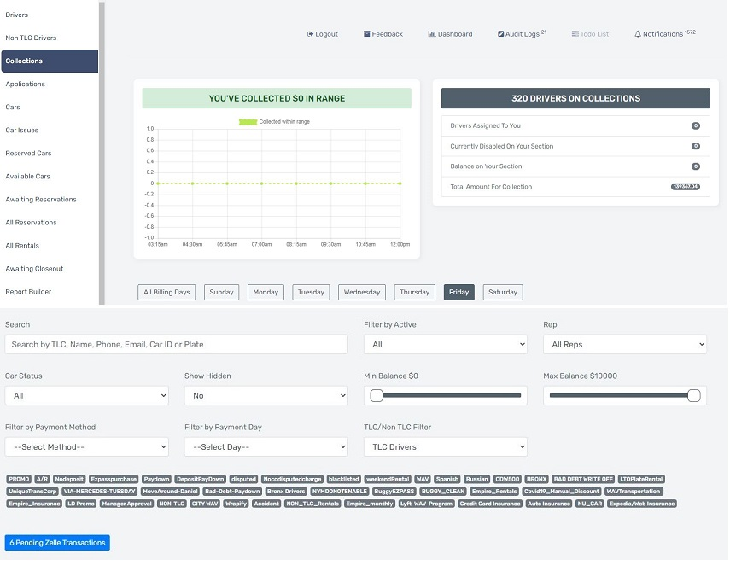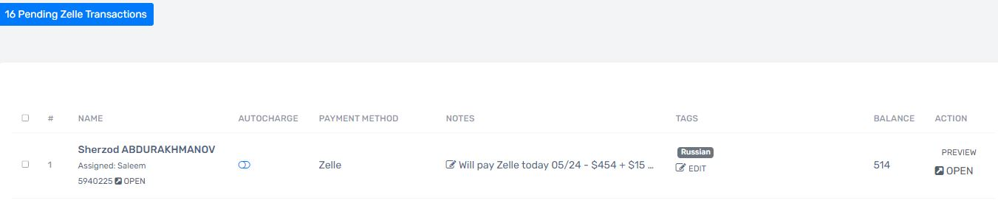

**Personal Collection Chart:**

The personal collection chart is a chart that shows how much payment has been collected by a person including **card charges** and **Zelle payments added** into the accounts. The collection chart has time slots showing how much money is collected at what time or in which time slot.   
 Above is the image of the **“Personal Collection Chart”**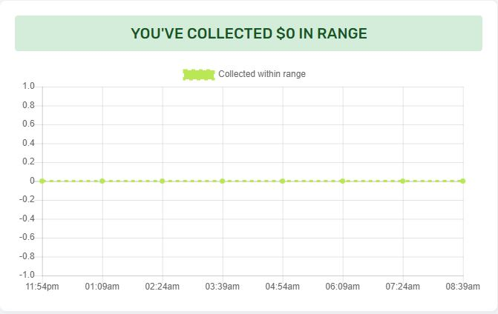

Above is the image of the **“Filter Date”** feature in the **Personal Collection Chart**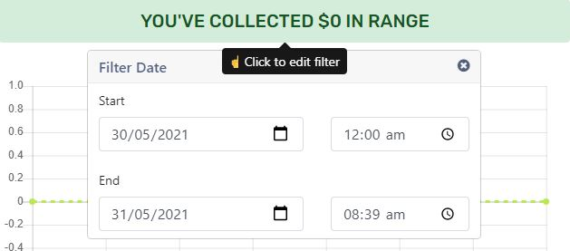

**Filter Date:**

It has a **Filter Date** feature that allows you to select a date or different dates (Start-End date) with a time selection option that can help you view the collection chart as desired.

**Number of Drivers on Collection Board:**

In the billing department, the user has to do follow-ups with several **drivers assigned** to collect a specific amount of money each day. And this section shows how many drivers are there for a user and how much **balance is in the user’s section** depending upon the number of drivers and their balance. It also shows how many drivers are **Disabled** in the user's section and also shows the **total amount for collection**.

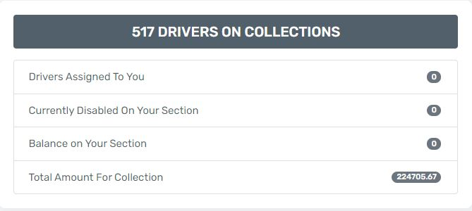

Above is the image of the **Drivers Collection Board**

**All Billing Days:**

In the **billing department,** the users have to do follow-ups on the drivers concerning their billing/invoice day and this is where the billing days feature is used. The user can select any day of the week or can click on the **all billing days** option to do a follow-up with all days drivers.



Above is the image of the **“Billing Days Bar”**

**Search bar:**

In the **search bar**, the driver can be searched by entering the **driver's name, TLC license number, Phone number, email address, or car id**.

* **Name:**  
   A driver can be searched by entering the name of the driver but since the BOS works with the relevant search other drivers having the same name might show up.
* **Phone Number:**

A phone number is necessary to contact the driver via call or text message.

* **TLC License:**

A TLC license is a license given by the Taxi & Limousine Commission to the person, eligible to drive the car for the taxi or limousine services. Only TLC License holders can drive the car for commercial purposes.

* **Email address:**

An email address is necessary to send the rental contract, important documents, important notices and used for formal purposes.

* **Car id:**

A car id is an identification number, every car in Buggy has a special car id number to find out the car in BOS and to easily assign it to the drivers.

* **Plate:**

The car will also be searched with the Plate number starting with the letter **T** and Ending with the letter **C,** in between 6 digits will be written.

**Filter by Active:**

* **Active Status:**

Active status indicates that a driver is currently working with Buggy. 

Above is the image of the Stage of **“Active Driver”**

* **Past status:**

Past status indicates that a driver is not currently active with Buggy but the driver was associated with Buggy in the past.

Above is the image of the Stage of **“Past Driver”**

**Rep:**

Rep dropdown menu is used to select a representative’s name from the list, the user will click on its name and will continue with the assigned section.

Above is an image of the **“Rep Dropdown Menu”**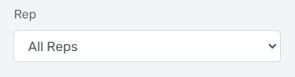

**Car Status:** Car Status is another feature that helps the users to search for the cars which are **Disabled** or **Enabled** by the users in Buggy.

* **Disabled:**

Disabled status indicates that the car is disabled from the tracker by the user and is not turning on. The driver needs to contact Buggy representatives to get the tracker enabled.

* **Enabled:**

Enabled Status indicates that the car is Enabled from the tracker.

Above is an example of the status of the car is **Disabled.**

**Show Hidden:**

This option is used to show the hidden drivers from the collections. Billing representatives have an option to hide a driver if that driver owes us less amount of money, usually less than $20. This option will show all the hidden drivers only. 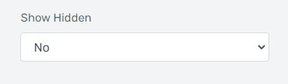

Above is the image of the **“Show Hidden Menu”**

**Min Balance - $0:**

Min balance adjuster is a controllable bar from which a user can adjust a minimum balance as desired to classify the drivers.

**Max Balance - $10000:**

Max Balance adjuster is a controllable bar from which a user can adjust a maximum balance as desired to classify the drivers.

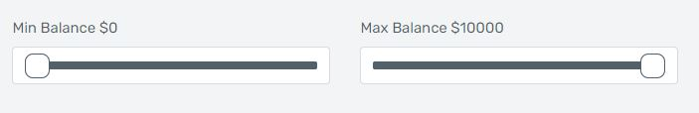

Above is the image of the **Min Balance & Max Balance adjusters**

**Filter by Payment Method:**

This filter is used to differentiate between the drivers concerning their payment method.

**Here are the different Payment methods:**

* Zelle
* Remote Cash
* Payment Link
* Credit/Debit Card
* Cash/Card Swipe in Office

**Zelle:**

A Driver can pay through Zelle/QuickPay on the Buggy billing email: [billing@joinbuggy.com](mailto:billing@joinbuggy.com) and it will not cost any fee or extra charges. The driver will open the Zelle account and after writing Buggy’s email in the email section, will also write the TLC license number or plate number of the car in the **Memo** section.

**Remote Cash:**

Remote Cash link is a barcode link through which a driver can pay in cash on some specific stores like, **7-Eleven, Family Dollar, Dollar General, Kum & Go, CVS pharmacy,** and a few others. The driver will go there and show the barcode link received from Buggy TLC then the clerk will scan the barcode and the driver can pay in cash the amount driver wants to pay for the due rent and the driver will be charged a **$2** convenience fee on top of each transaction.

Above is the example of the **“Remote Cash bar code”**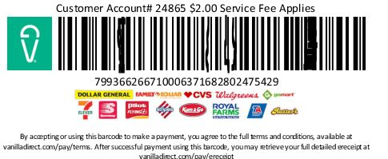

**Payment Link:**

A payment link is a feature in Bos from which a link can be sent to the driver and the driver can make the payment using a credit/debit card without getting it saved anywhere. The driver will be charged a 3% bank processing fee on each transaction which will be added by the user manually in the payment link amount.

Above is the image showing the **“request payment link button in Stripe”**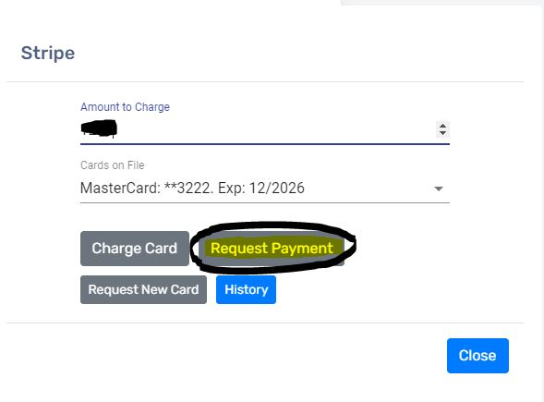

**Credit/Debit Card:**

A driver can pay through a credit card or debit card saved on the system or can provide a new card along with the pictures of the card with the driver’s name on it and the billing department can charge the card for the payment if required. The driver will pay a 3% bank processing fee on each transaction. The card will be saved on file and the user can charge the card by clicking on stripe and check the last 4 digits of the card and will charge it if required.

Above is the image showing the **“Charge Card button for the Stripe”**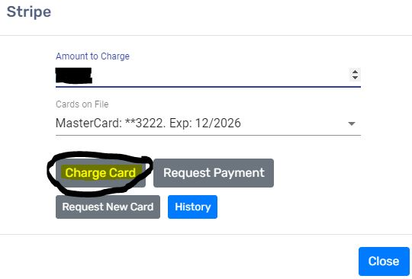

**Cash/Card Swipe in Office:**

As clear from the name, the drivers can pay their due rent or can make an upfront payment in the office in **cash** without any extra charges.

Just like the payment in cash, the drivers can also pay by the **card swipe** through the swipe machine without getting charged any extra fees.

To make the payment in cash or to swipe the card, the driver can visit the office between 9 am to 5 pm from Monday through Friday.

Here is the office address: [**445 Empire Boulevard, Brooklyn, NY.**](https://www.google.com/search?q=445+empire+blvd+brooklyn+ny&oq=&aqs=chrome.0.69i59i450l8.17893j0j7&sourceid=chrome&ie=UTF-8)

**Filter by Payment Day:**

“Buggy” always tries to help drivers in case they need any assistance, so if a driver who picked up a car cannot pay the rent on the same billing day next week. Or somehow the driver gets paid by some private base or another company that pays on a specific day that doesn’t match the current billing/invoice day of the driver, Buggy as a courtesy allows drivers to choose some other day with their payment method. This is how the driver has the same billing day as before but can pay on some other specific day every week.

The above image is the demonstration of **“Filter by Payment Day”**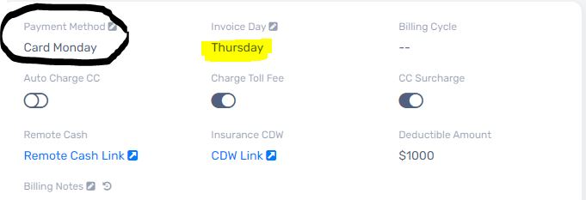

**TLC/Non-TLC Drivers:**

This option allows us to search the TLC or Non-TLC drivers for billing purposes**.** There is a dropdown menu that allows the user to choose between TLC or Non-TLC drivers.

Above is the image of the **“TLC/Non-TLC drivers dropdown menu”**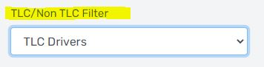

**Tags:**

This feature allows the user to search the drivers with a specific tag. If a driver’s profile needs special attention like the driver is on a payment plan or if it’s a Bronx Driver, the driver’s profile is tagged with (Paydown), (Bronx Drivers).

**Pending Zelle Transactions:**

The pending Zelle transactions button is used to add the payment of the drivers into their profiles who sent them using the Zelle/quickpay method.



Above is the image showing the **“Pending Zelle Transactions Button”**

**By clicking the above button** it will open a hovering window having the pending Zelle payments which are supposed to be added to the driver’s profile.

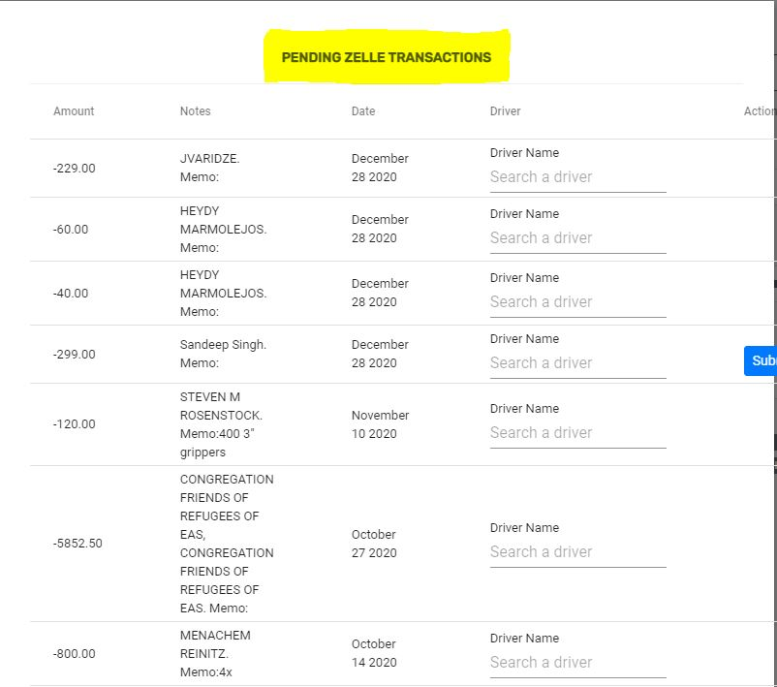

The above image shows the **window** opened by clicking the **“Pending Zelle Transactions Button”**

**Hide Drivers button:**

**The hide drivers button** is used to hide the driver from the billing in case the driver paid most of the balance and the remaining balance is around **$20.** The use of this feature is recommended after the billing manager’s confirmation. The **user** can select one or more drivers to hide at the same time.

Above is the image for the **“Hide Drivers button”** 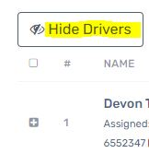

**Message Drivers button:**

**The message driver button** is used to send the text messages to the drivers using BOS. The message can be of several types like a message for billing purposes, for car switch or car reservation, or regarding the return purposes. The message can also be about the maintenance of the car. The user can select one driver or several drivers altogether and write a message to send it in one go.

The above image is a demonstration of the use of **the “Message Drivers button”**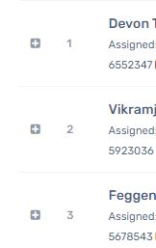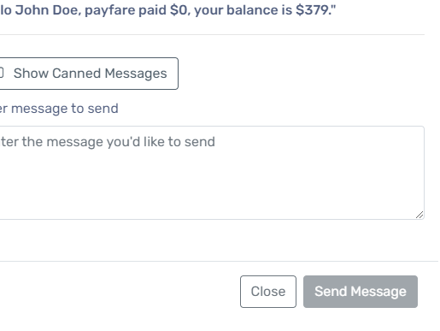

**Applications Page:-**

**The applications page** involves all the data related to the **applications** and the **insurance** of the drivers. It includes **5** different sections as **New Applications, Pending Insurance, Denied, Didn’t Take the Car, All Applications.** Other than this it has a **search bar**, **Rep** dropdown menu, and **Filter by Insurance Status.**

Above is the image showing **“Applications Page”**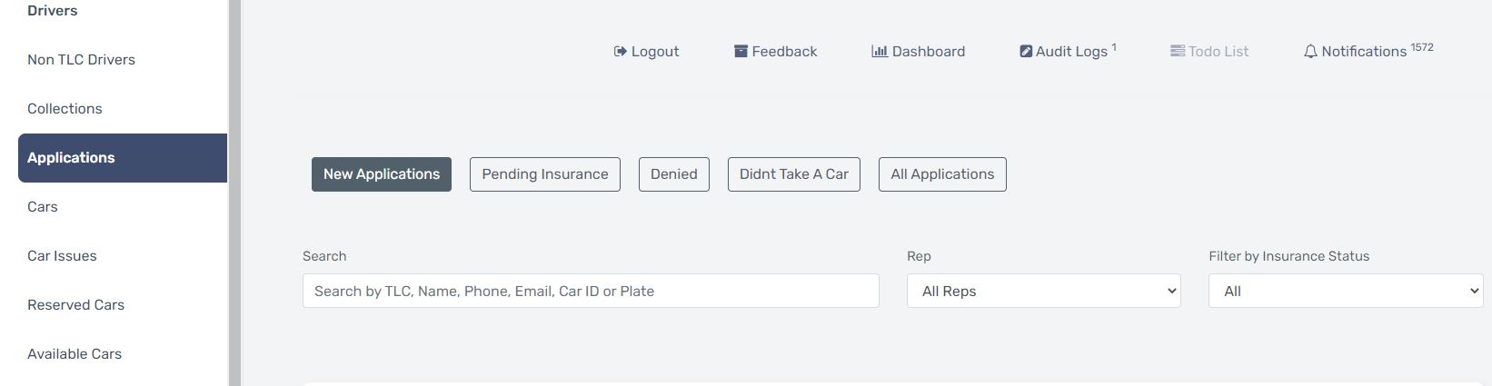

**New Applications:**

Whenever a new driver applies for a car for the very first time, the driver fills out an application form and once it's submitted by the driver. It will be displayed in the **new applications** section.Then one of our agents reached out to the driver and explained to them everything required in order to pick-up the car. After that the agents create a reservation if the driver agrees to pick-up.

The New applications section has a board with the drivers who have applied for a new car, the board has the following information in regards to the driver:

* Name - **Driver’s name** with an **action** option of **open**
* Notes - **Notes** by the agent/user
* Pickup Location - From where the car can be **pickup**
* Applied on (Date) - The **date** driver applied
* Duration - How much **time has passed** since the driver applied
* Base Status - VIA: **Active** or **Inactive**
* Start Date Wanted - When driver wants to **pick up** the car
* Action - It includes a **preview** and **open** option



Above image is referring to the **New applications** section

**Open from name or Action option:**

The option to open a driver’s profile in the New applications section enables the user/agent to open the **DRIVER PROFILE** by default which contains the information about the driver as if the driver has a specific tag or if the insurance is active or inactive or if there is any specific note in the driver’s profile.The **DRIVER INFO** section has all the basic information that includes driver’s first and last name, email address, phone number, TLC and DMV License and the physical address of the driver. There is another section called **DRIVER MESSAGES** from where a user/agent can check the messages history with that specific driver if any.

**Driver Profile:**

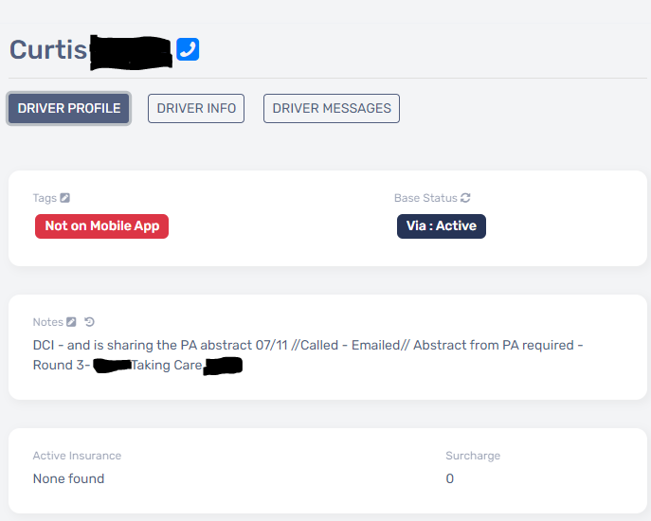

Above image is referring to the **Driver Profile default page**